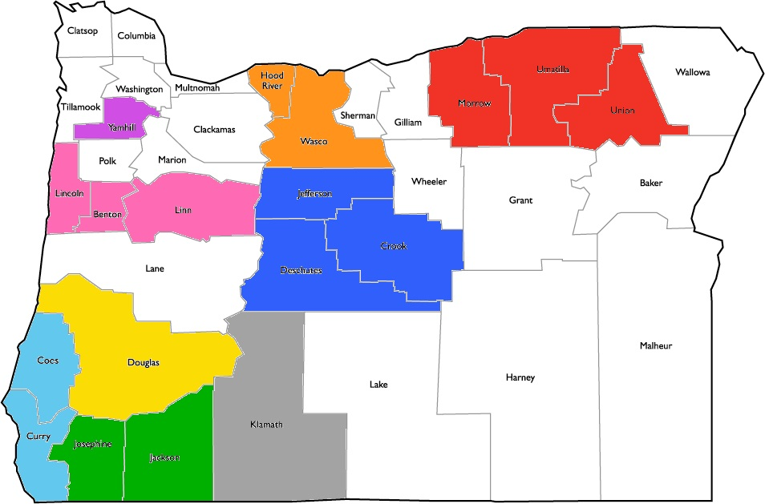
Oregon’s Local Oral Health Coalitions
Eastern Oregon Oral Health Coalition (In Formation)
Columbia Gorge Oral Health Coalition
Yamhill County Oral Health Coalition
Linn, Benton, Lincoln Regional Oral Health Coalition
Douglas County Oral Health Coalition (In Formation)
South Coast Oral Health Coalition
Central Oregon Oral Health Coalition
Southern Oregon Oral Health Coalition
Klamath County Oral Health Coalition (In Formation)
